**VISVESVARAYA TECHNOLOGICAL UNIVERSITY, BELGAUM 59014**



Website Development Report on

**“Hostel Management Portal”**

By

Eleanor Prashamshini(1BM16CS005) Aditi Awasthi (1BM16CS008)

Under the Guidance of

**Dr. Umadevi V**

Associate Professor, Department of CSE

BMS College of Engineering

Website Development carried out at



Department of Computer Science and Engineering

BMS College of Engineering

(Autonomous college under VTU)

P.O. Box No.: 1908, Bull Temple Road, Bangalore-560 019

2017-2018

**BMS College of EngineerinG**

**DEPARTMENT OF COMPUTER SCIENCE AND ENGINEERING**



***CERTIFICATE***

This is to certify that the website development titled “Hostel Management Portal” has been carried out by Eleanor Prashamshini (1BM16CS005) and Aditi Awasthi (1BM16CS008), during the academic year 2017-2018.

Signature of the guide

**Dr. Umadevi V**

Associate Professor

Department of Computer Science and Engineering

BMS College of Engineering, Bangalore

**BMS College of EngineerinG**

**DEPARTMENT OF COMPUTER SCIENCE AND ENGINEERING**



***DECLARATION***

We, Eleanor Prashamshini (1BM16CS005) and Aditi Awasthi (1BM16CS008), students of 3rd Semester, B.E, Department of Computer Science and Engineering, BMS College of Engineering, Bangalore, hereby declare that, this website development work entitled "Hostel Management Portal" has been carried out by us under the guidance of Dr. Umadevi V, Associate Professor, Department of CSE, BMS College of Engineering, Bangalore during the academic semester Aug-Dec 2017

We also declare that to the best of our knowledge and belief, the development reported here is not from part of any other report by any other students.

Signature

Eleanor Prashamshini (1BM16CS005)

Aditi Awasthi (1BM16CS008)

**1. Introduction**

Website development for “Hostel Management Portal”

This online management system supports the following users:

a. Resident Student

b. Warden

**Functionalities under Student login**

1. Can upload updated contact information, photograph and other details in the maintained database as per requirement
2. Application of leave to the Warden
3. Inquiry forum and request for repairs in the room
4. Receive notifications on attendance-related issues

**Functionalities under Warden login**

1. Addition/removal of students
2. Access and modify the list and details (branch, phone number, parent/guardian information, etc.) of the students according to the room numbers
3. Keep track of the attendance scenario of the students and option to send emails to the students and/or parents
4. Making announcements regarding Hostel Activities

**2. Webpage Screenshots**

2.1 Home

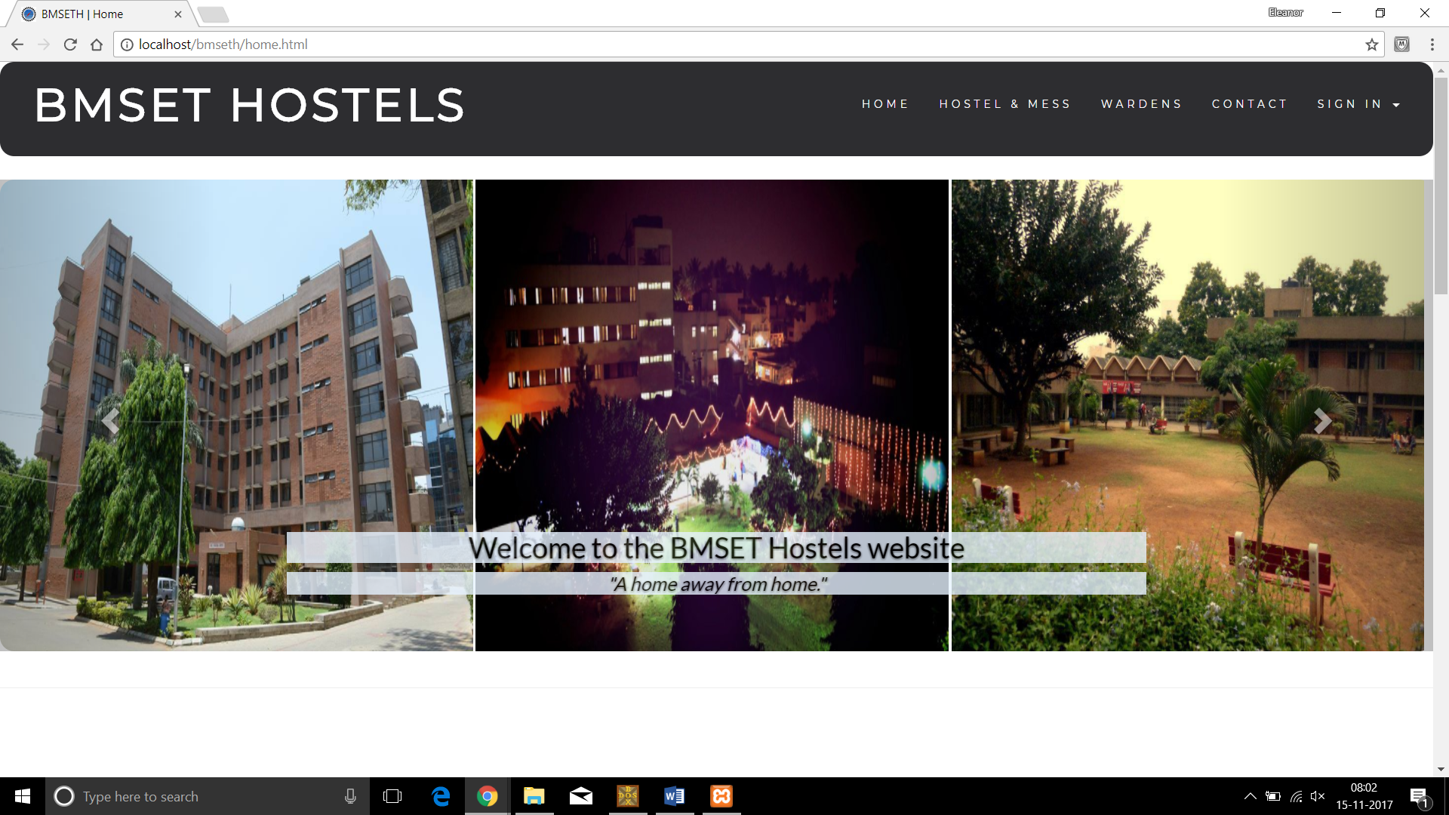

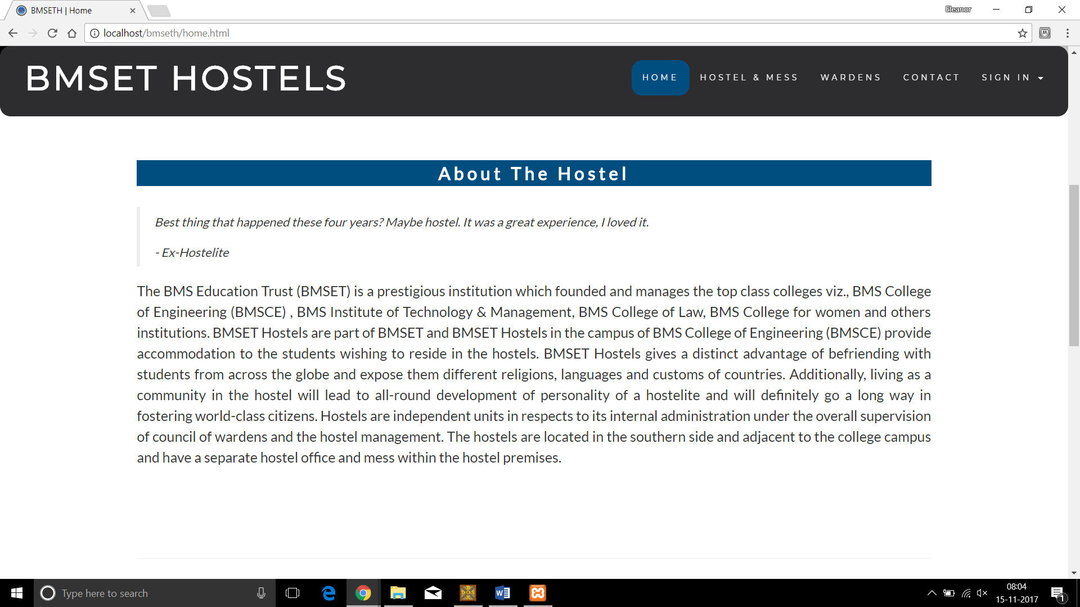

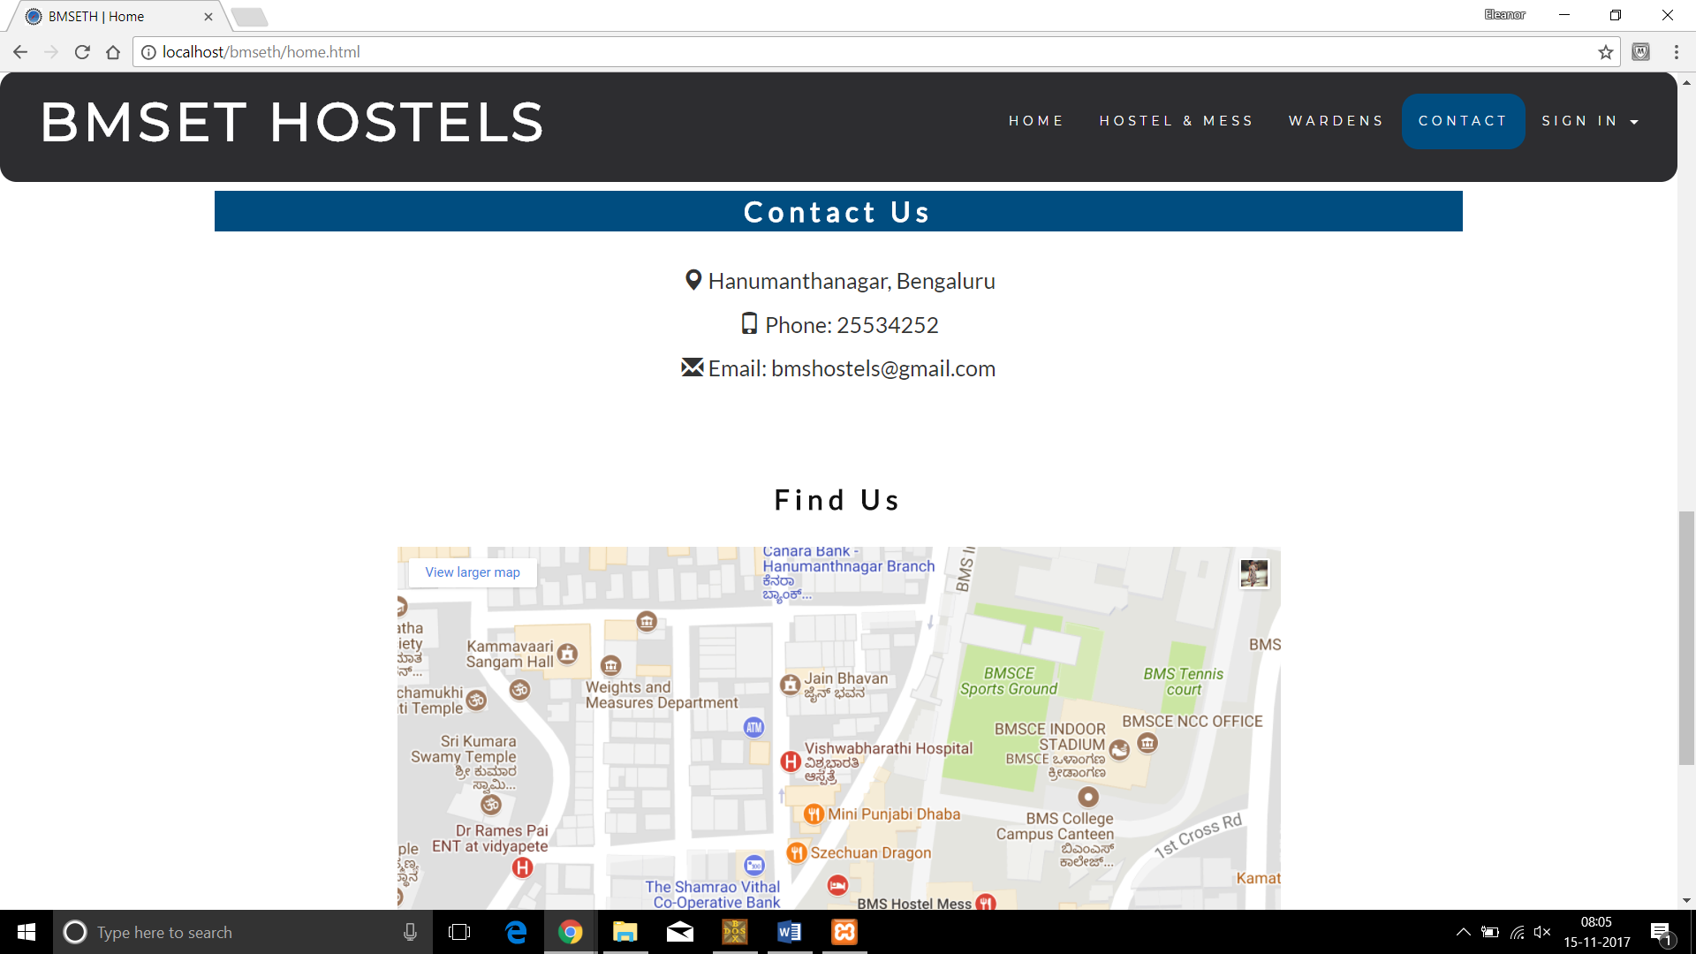

2.2 Warden

2.2.1 Sign In

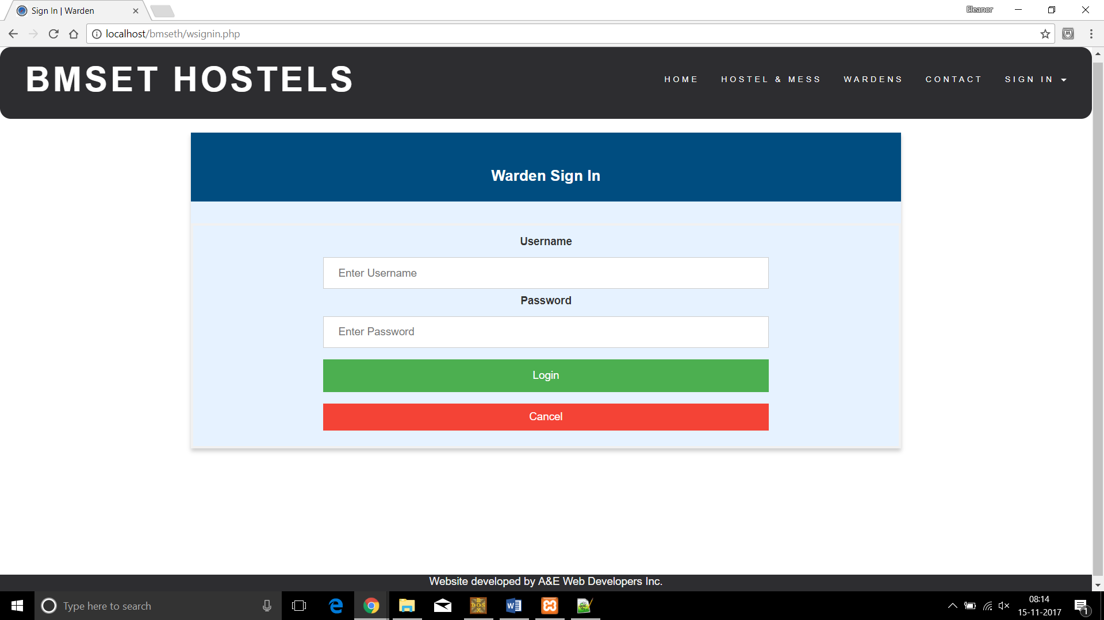

2.2.2 Landing Page

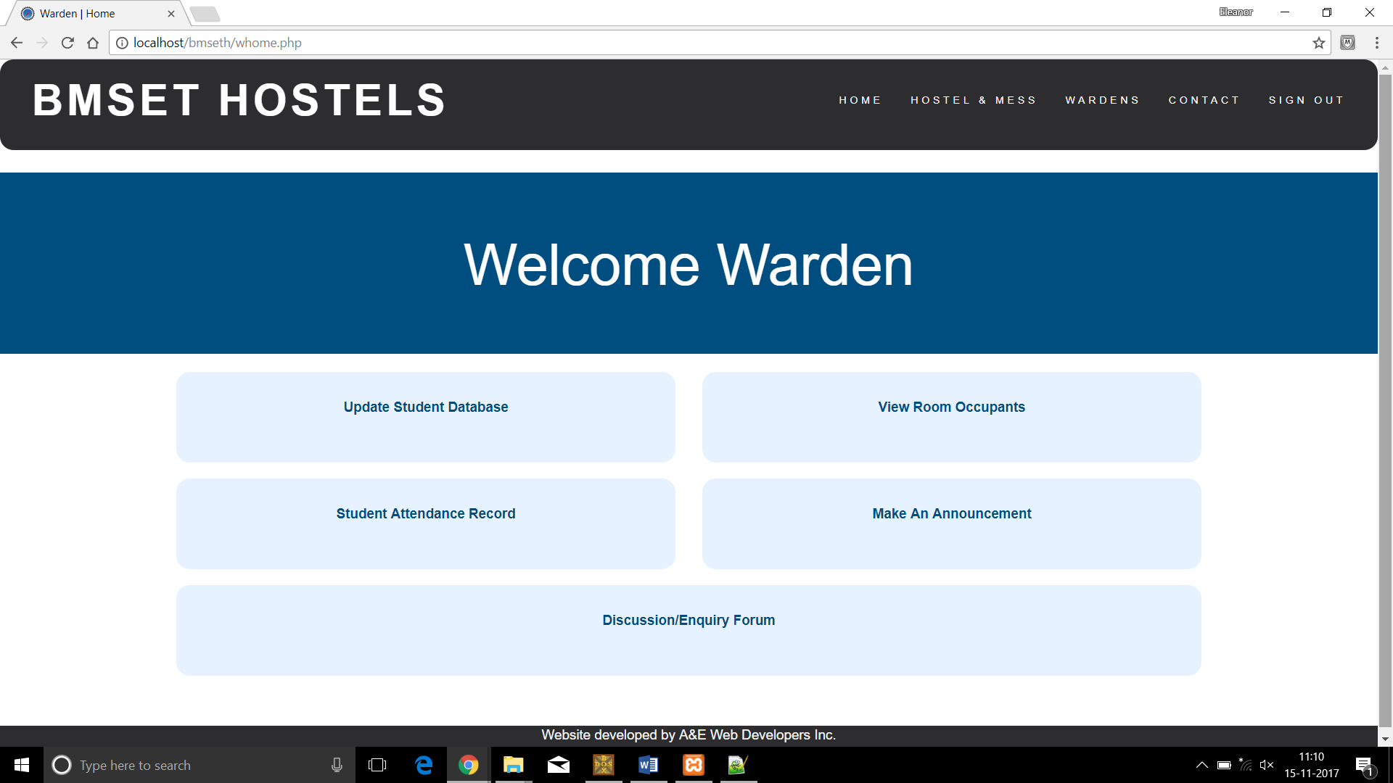

2.2.3 Search for Student

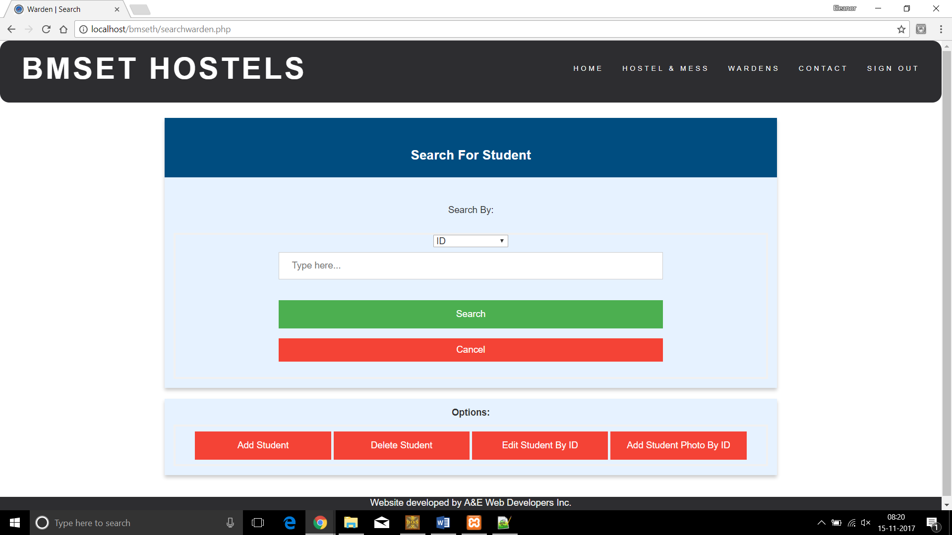

2.2.4 Search Results

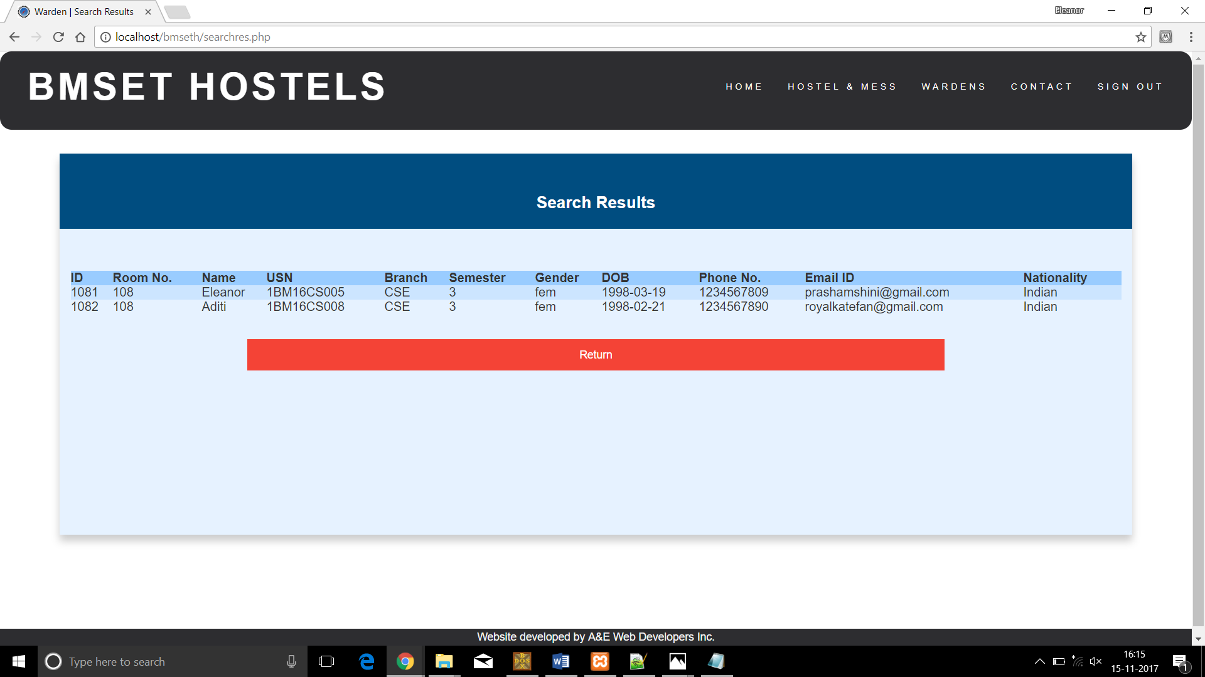

2.2.5 Add Student

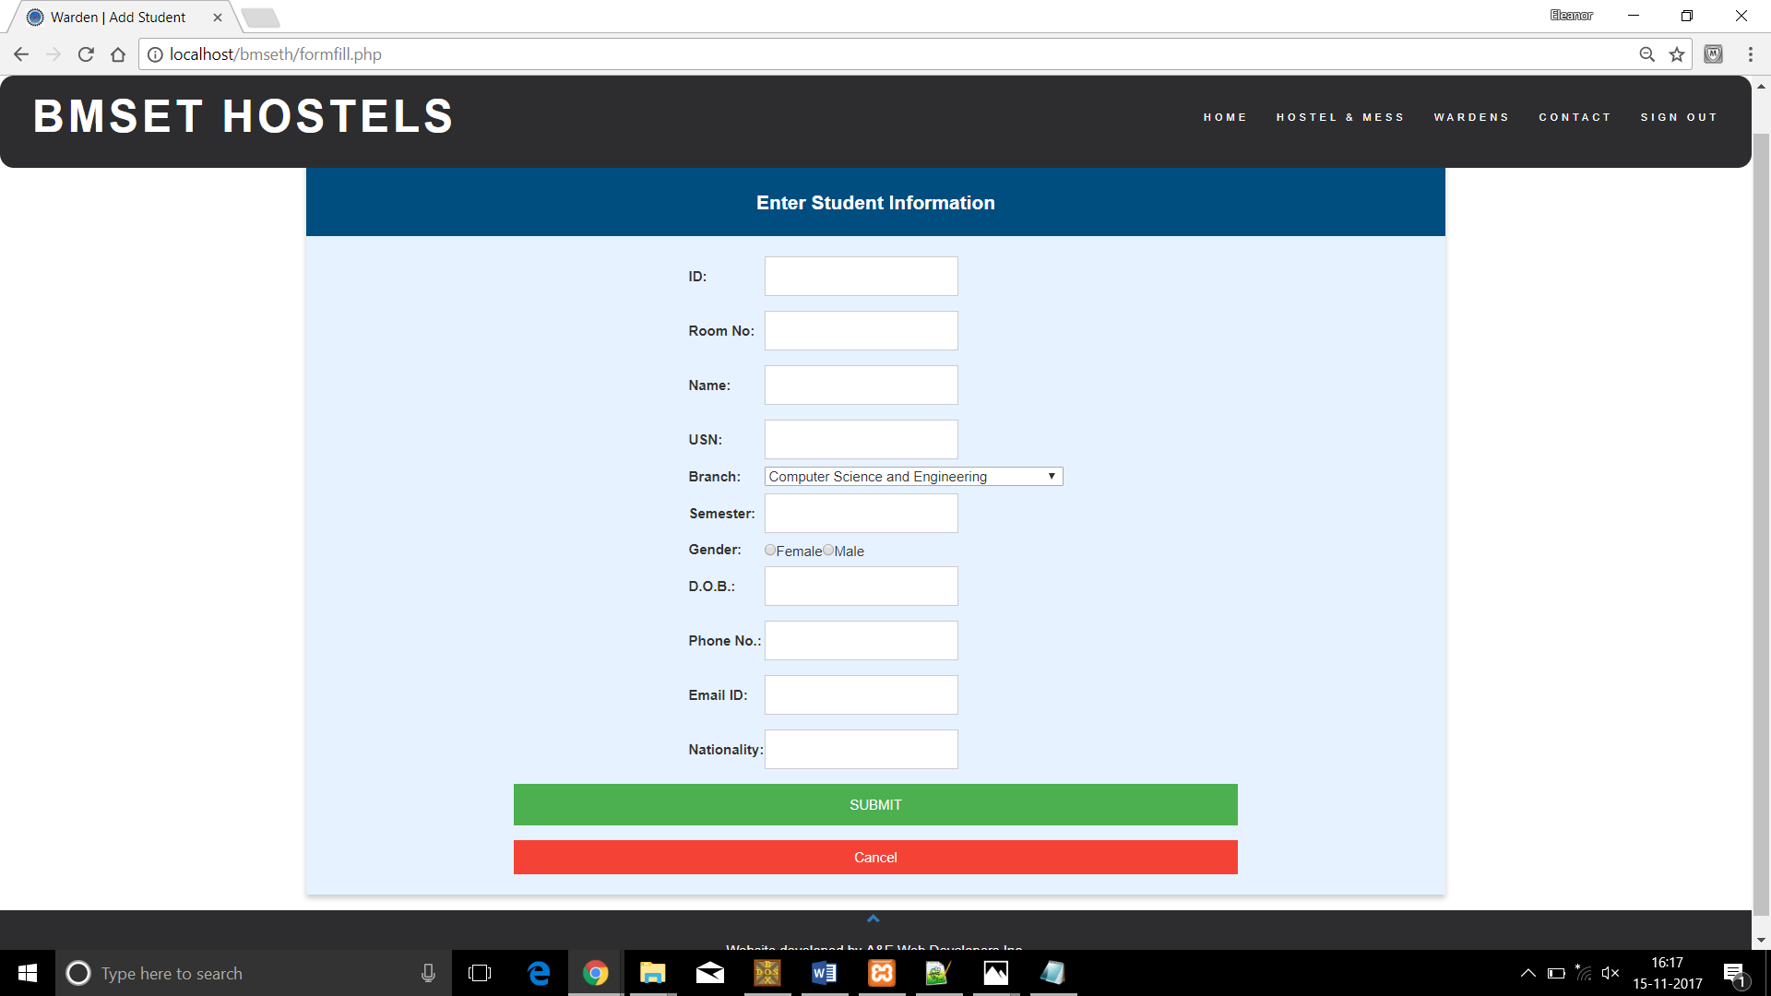

2.2.6 Delete Student

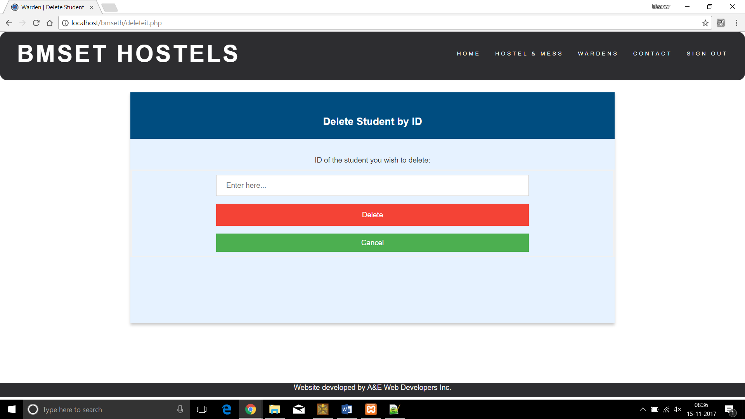

2.2.7 Edit Student Information

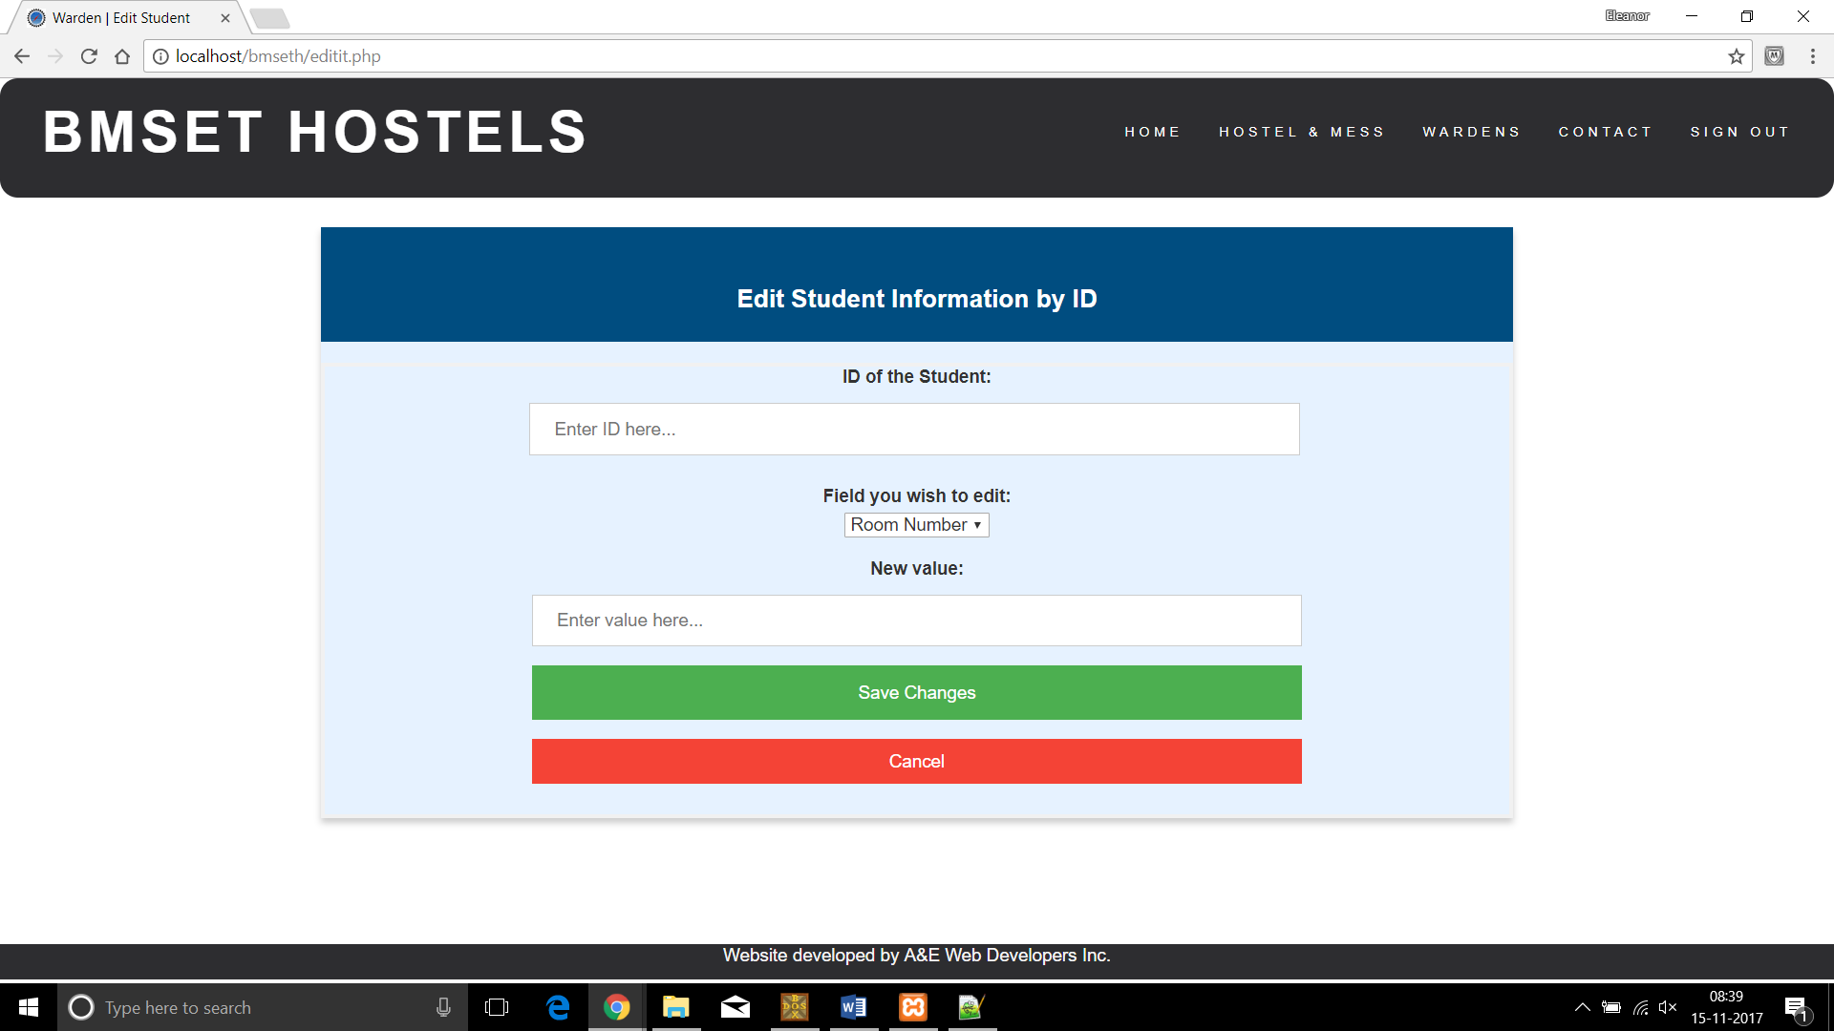

2.2.8 Add Student Photo

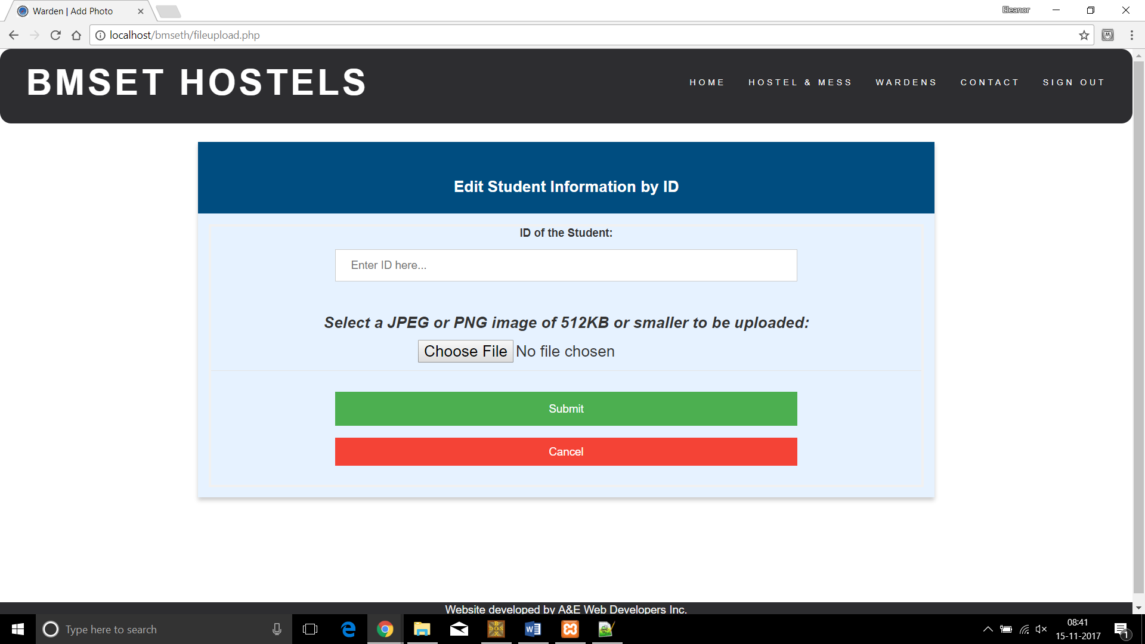

2.2.9 Room Numbers

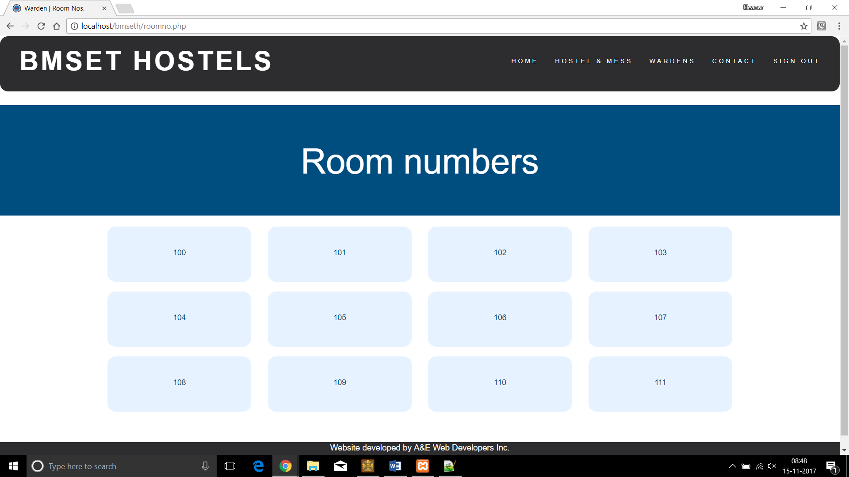

2.2.10 Student Details

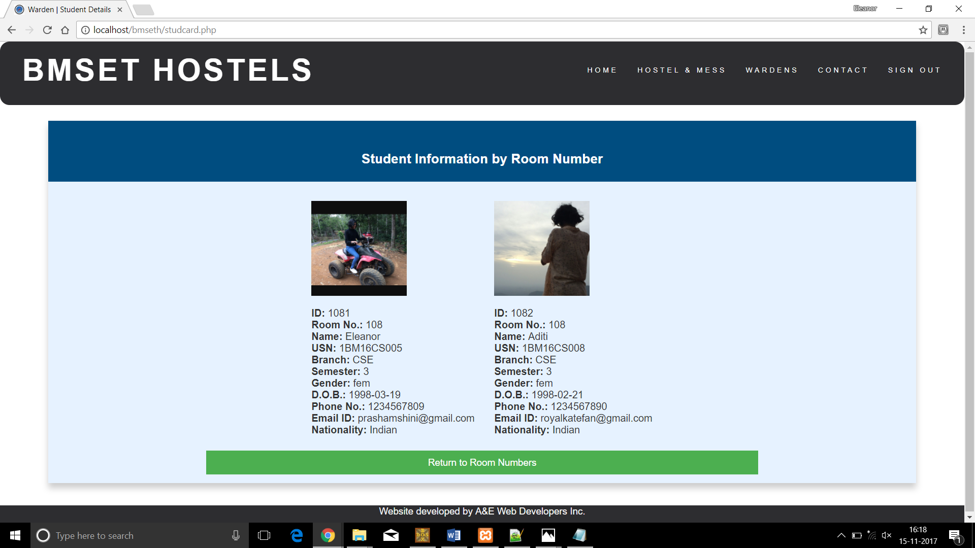

2.2.11 Attendance Record

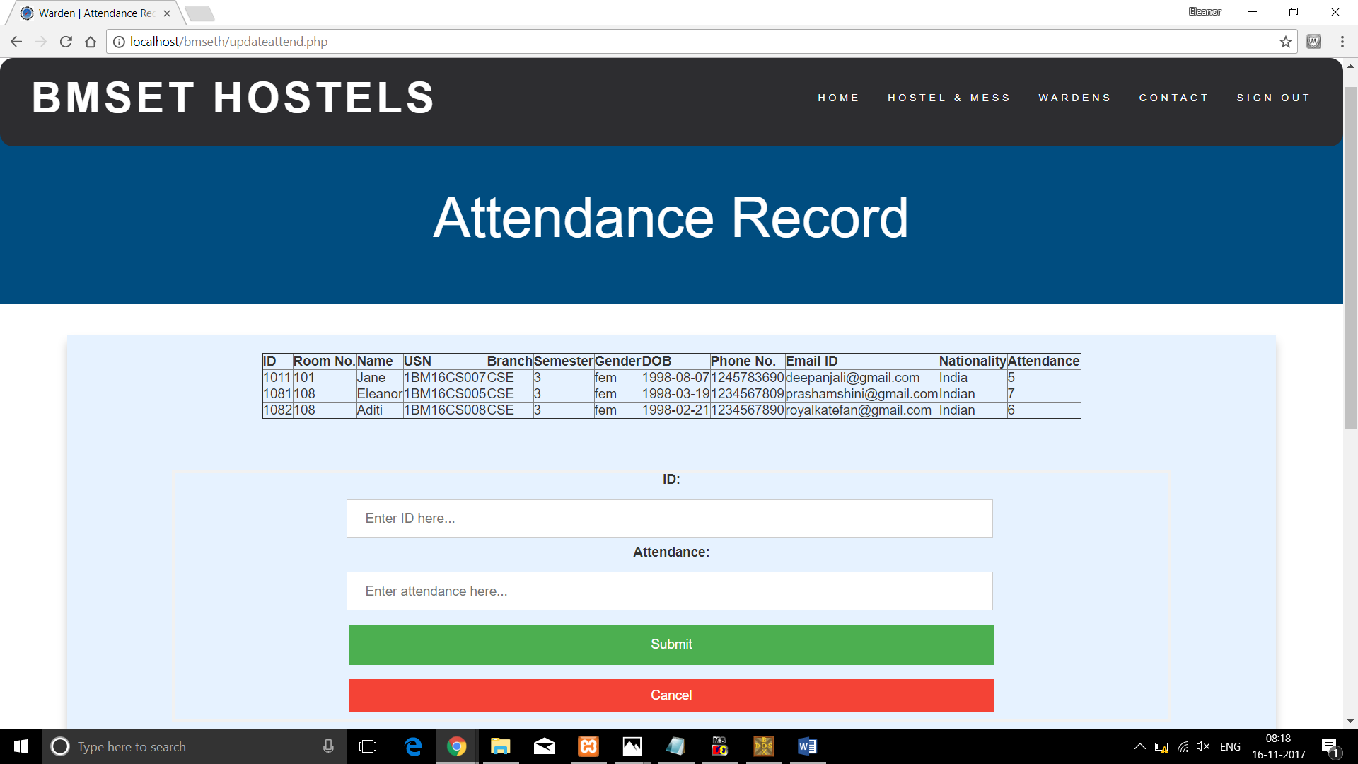

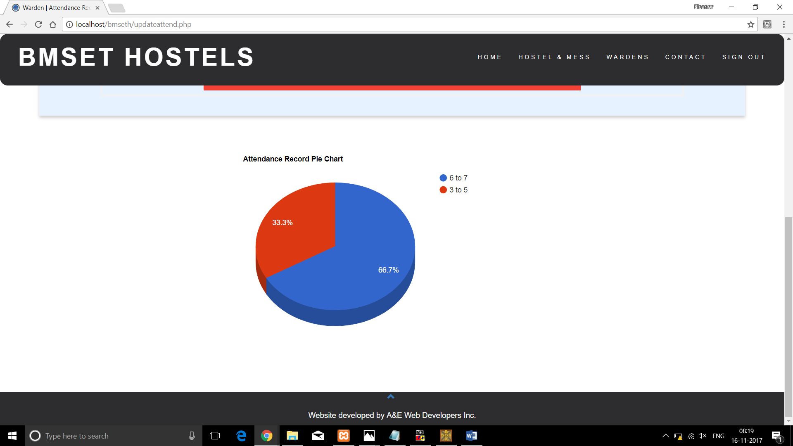

2.2.12 Making Announcements

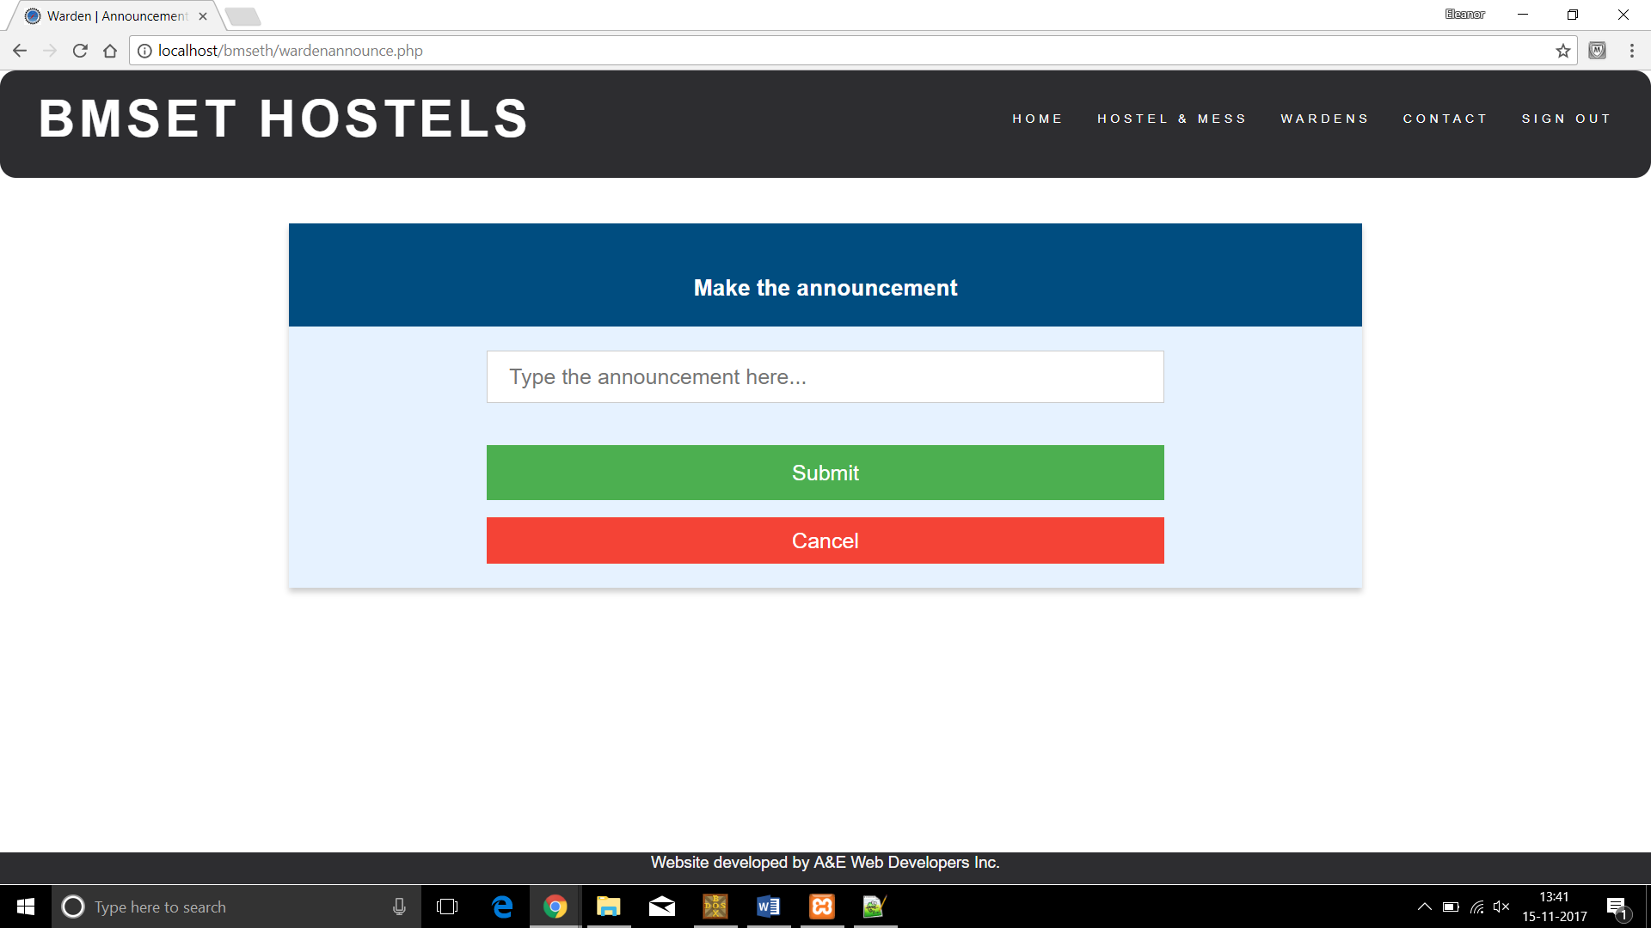

2.2.13 Discussion/Enquiry Forum

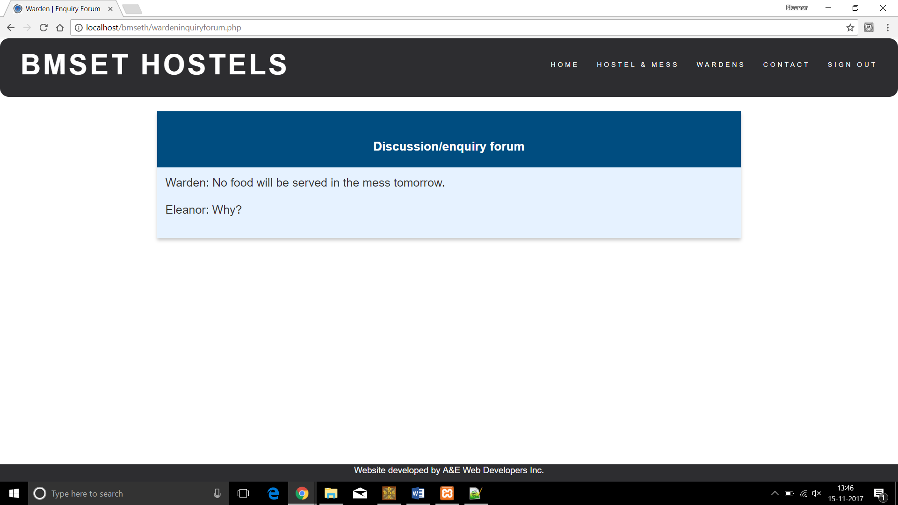

2.3 Student

2.3.1 Sign In

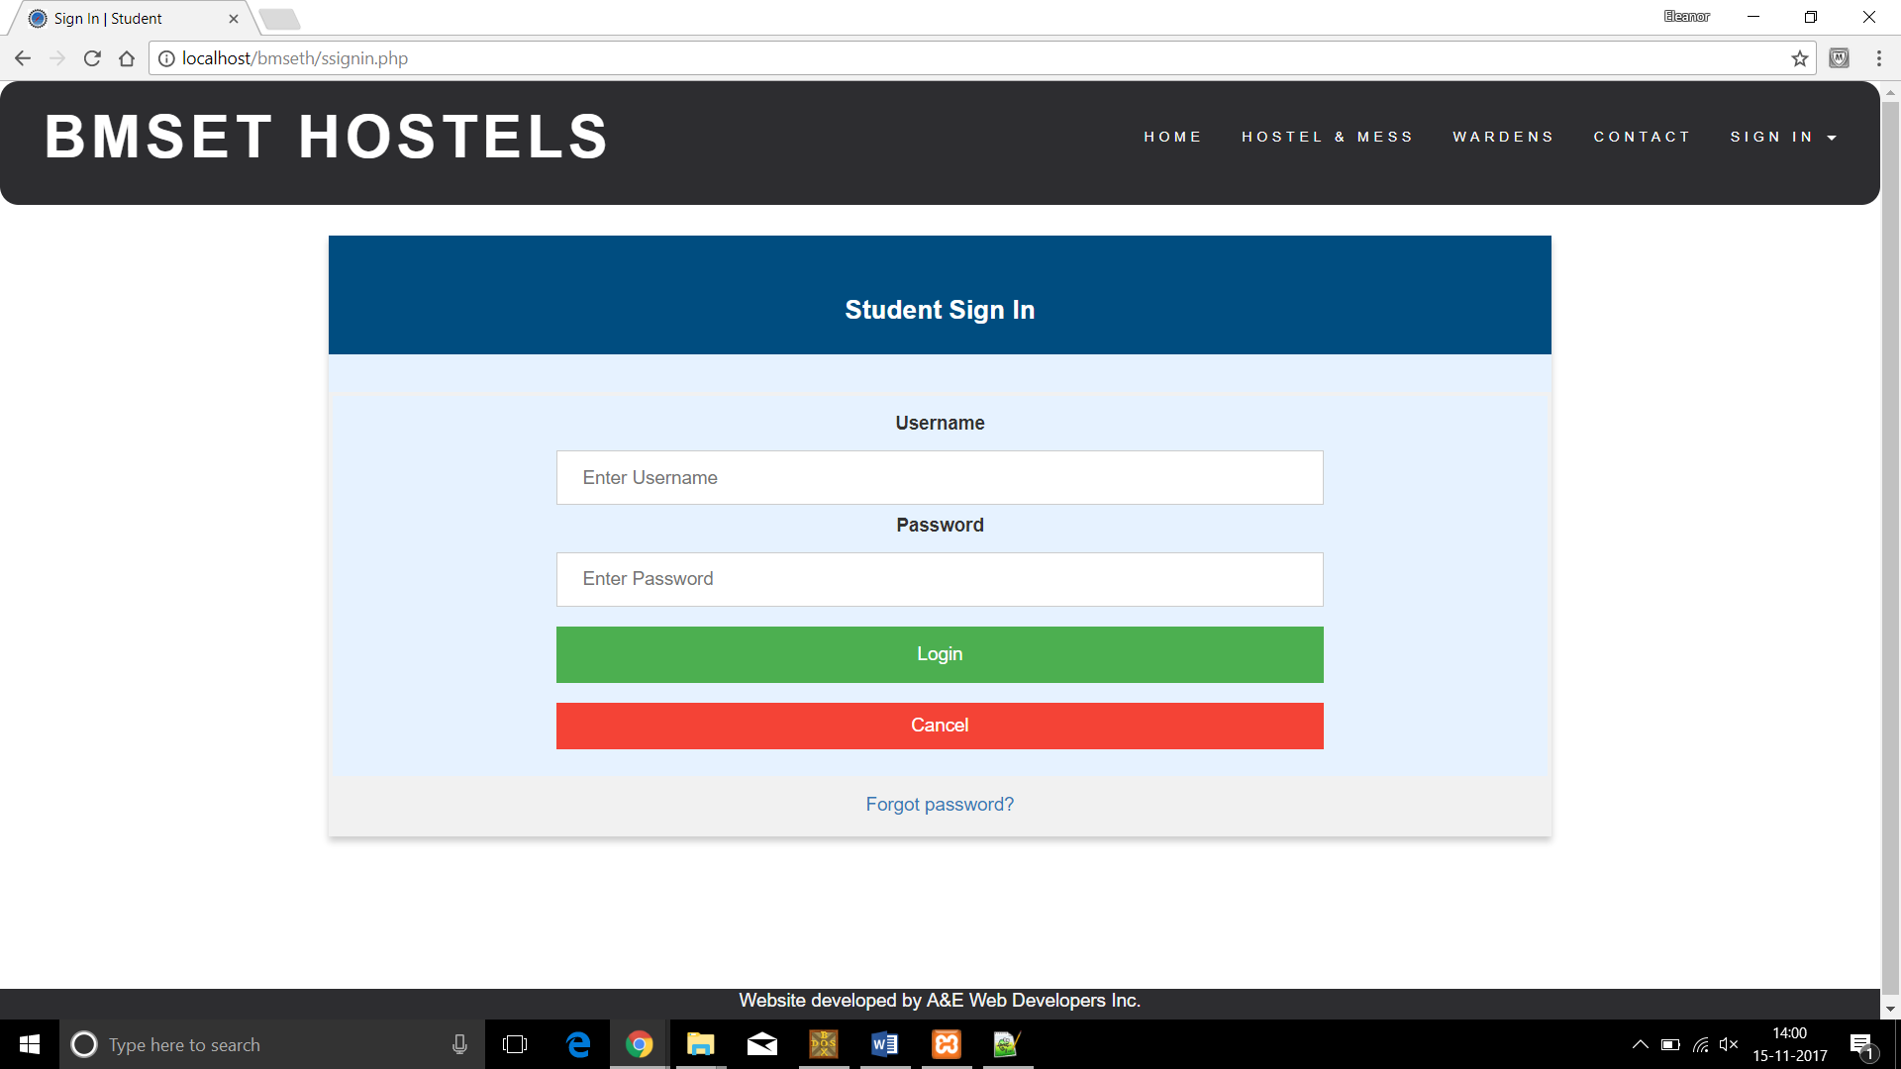

2.3.2 Landing Page

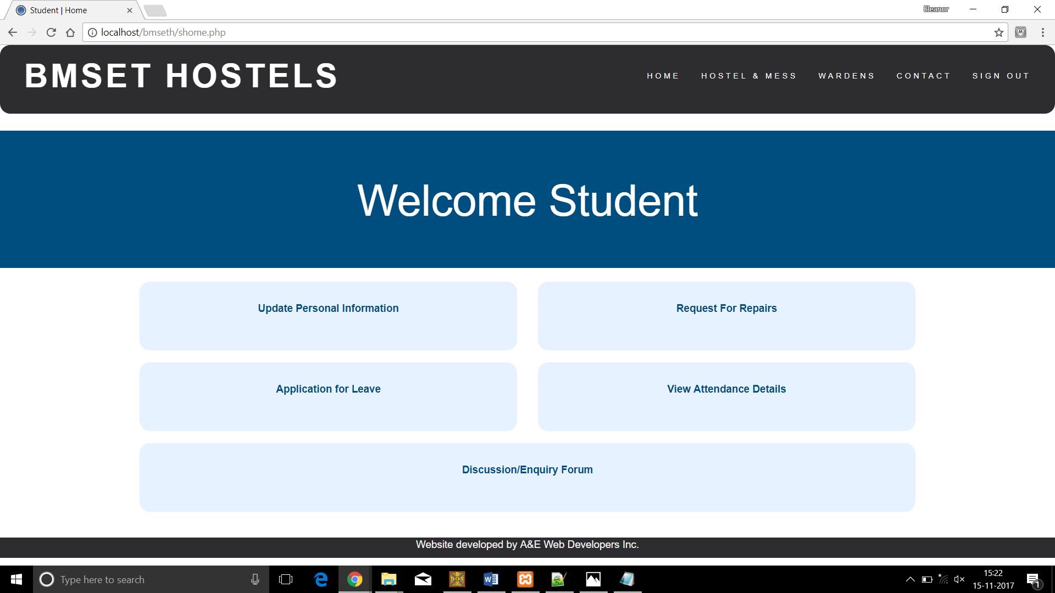

2.3.3 Personal Information

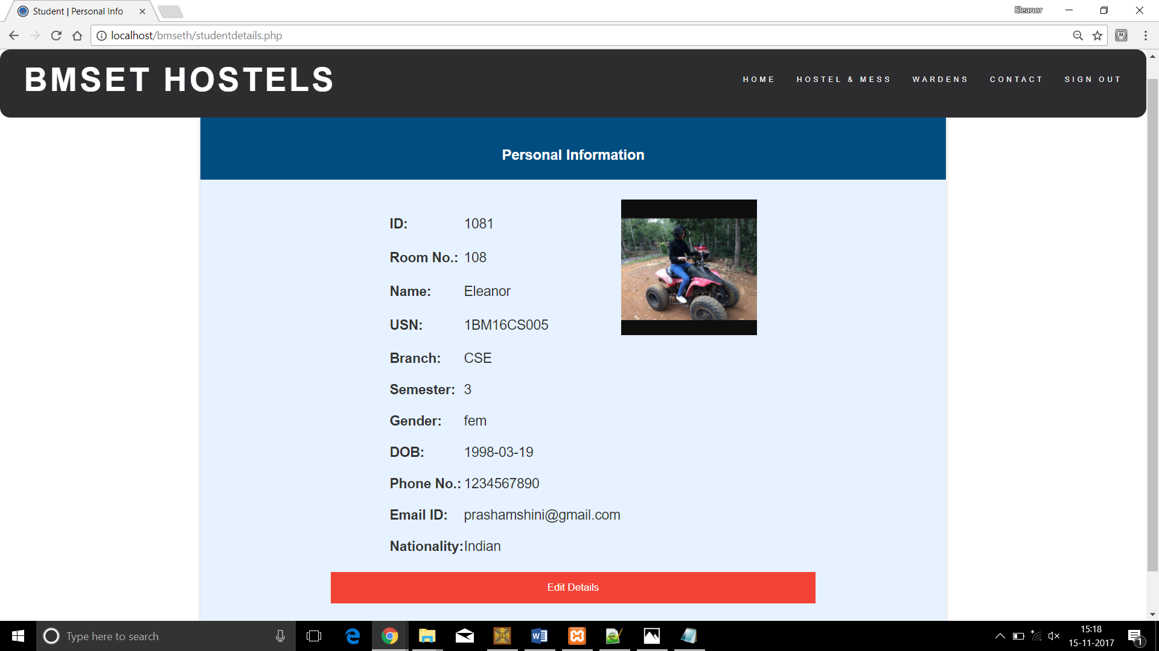

2.3.4 Request for Repairs

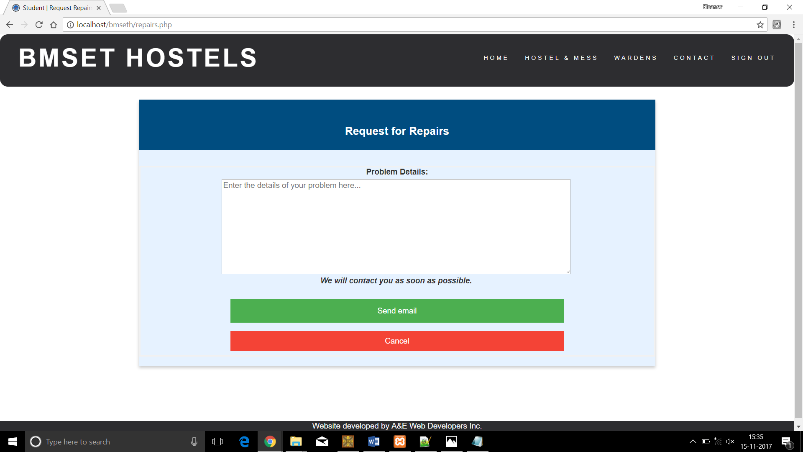

2.3.5 Leave Application

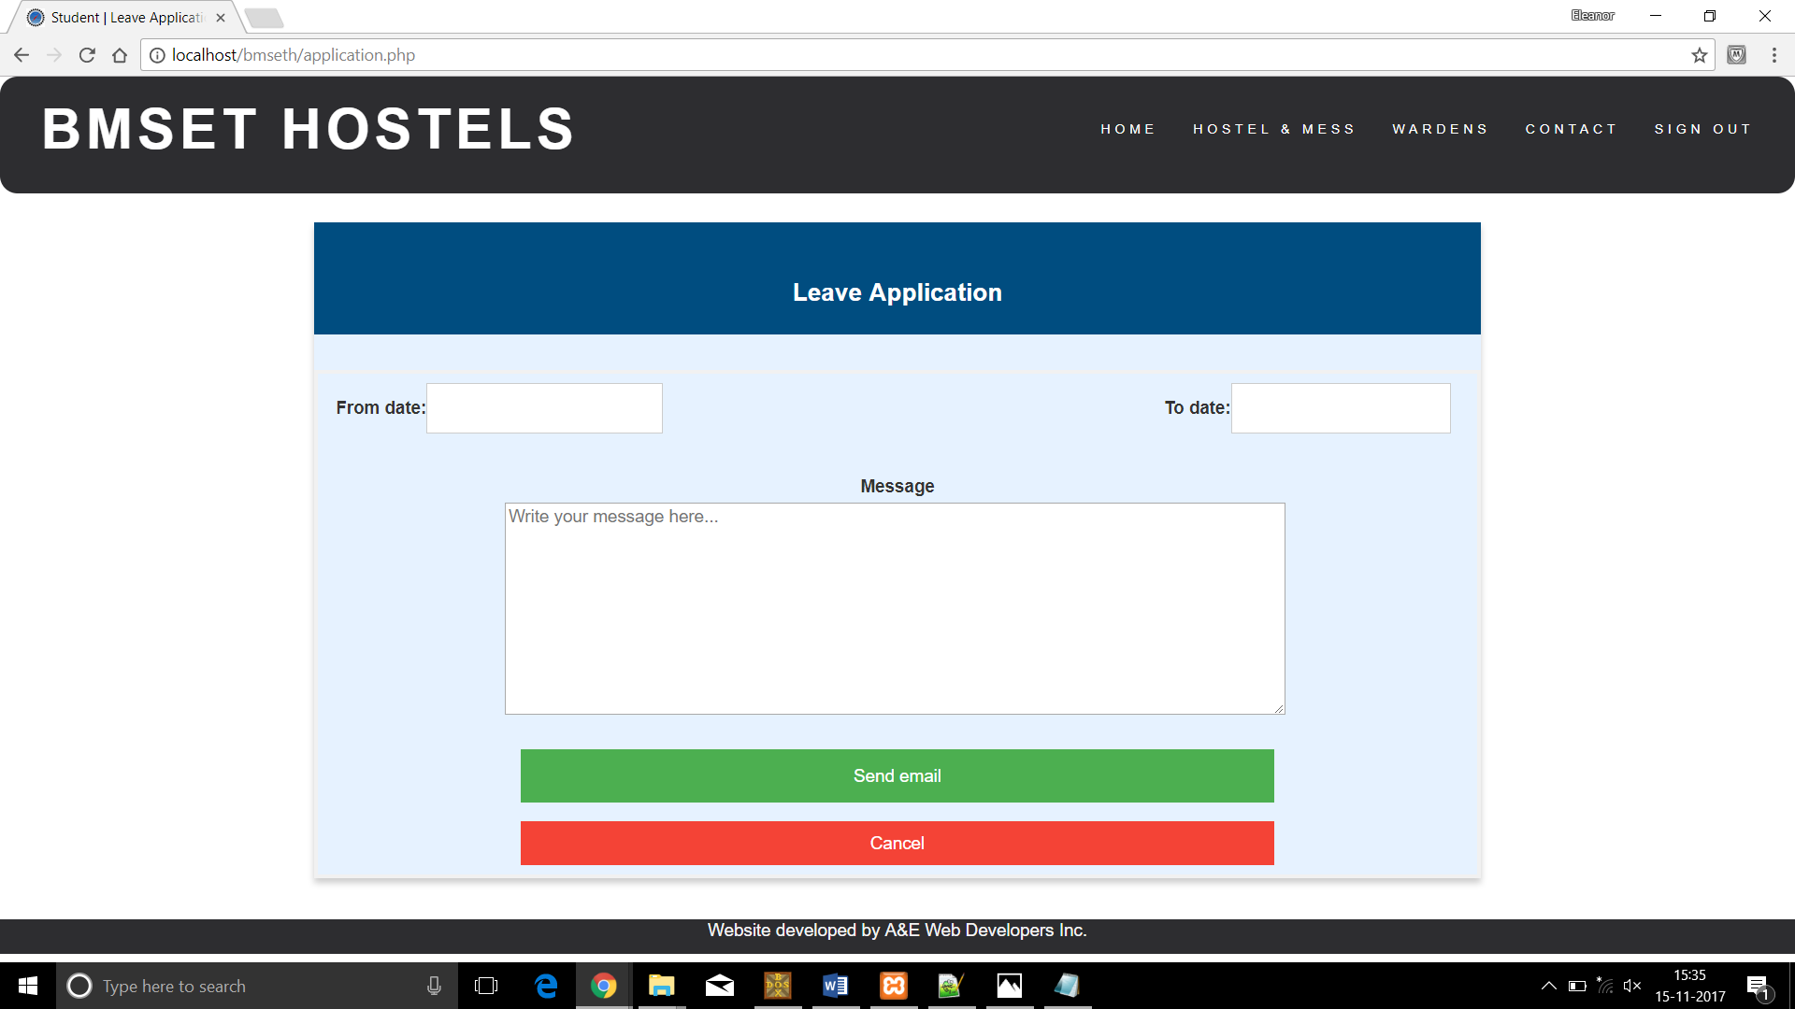

2.3.6 Attendance Details

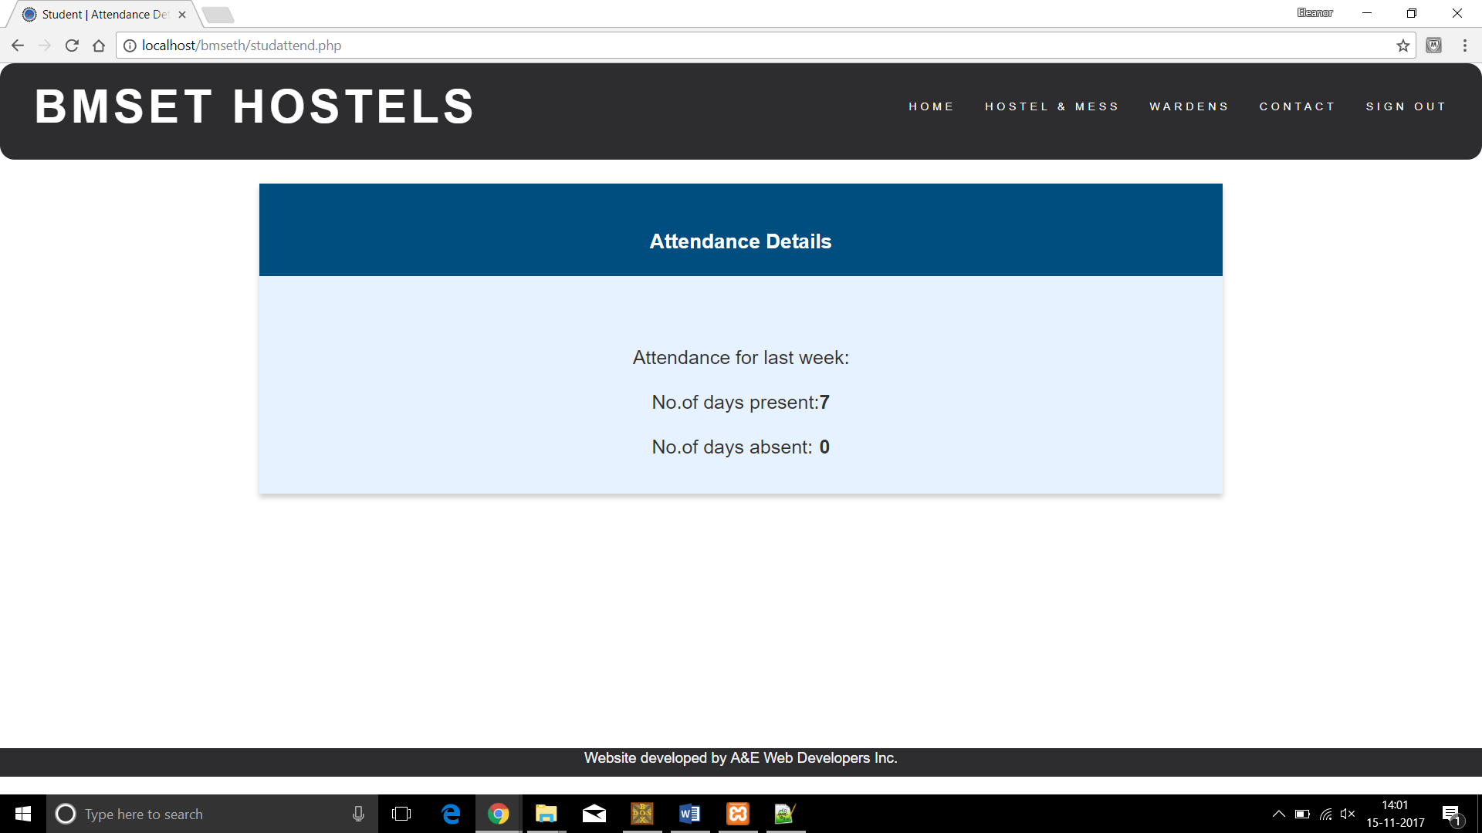

2.3.7 Discussion/Enquiry Forum

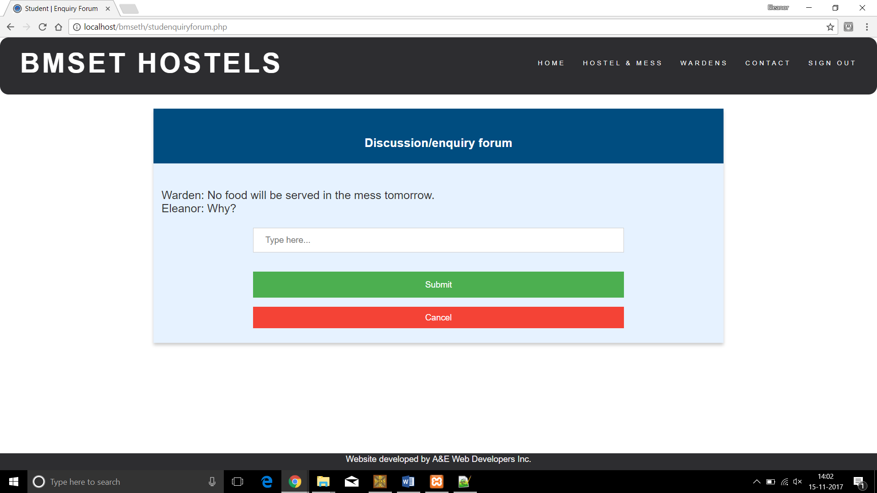

**3. Database Table Screenshots**

3.1 Warden User

3.1.1 Description

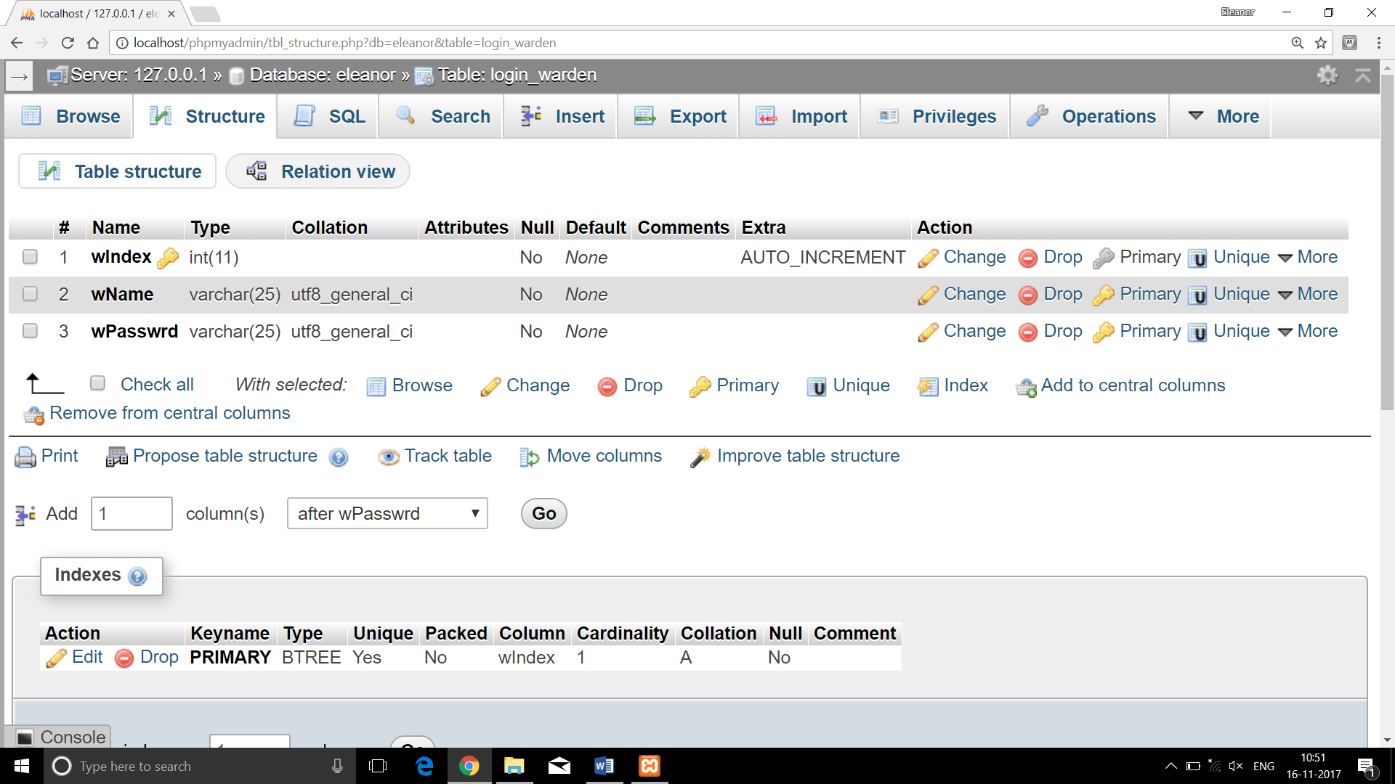

3.1.2 Data

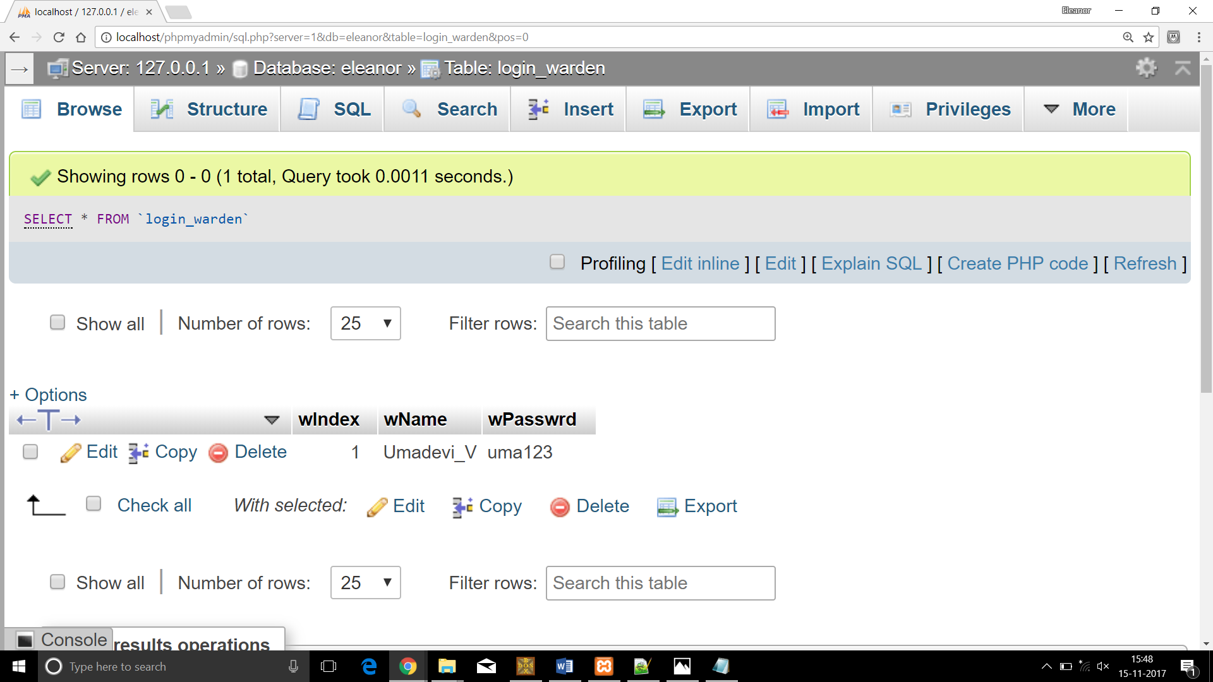

3.2 Student User

3.2.1 Description

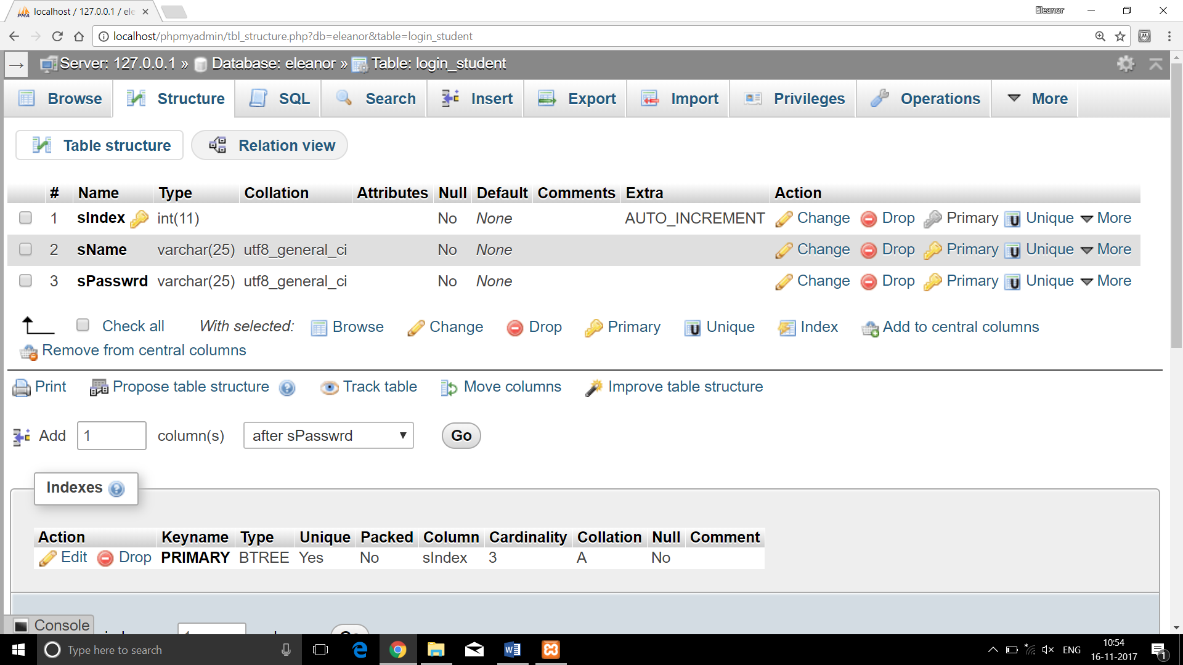

3.2.2 Data

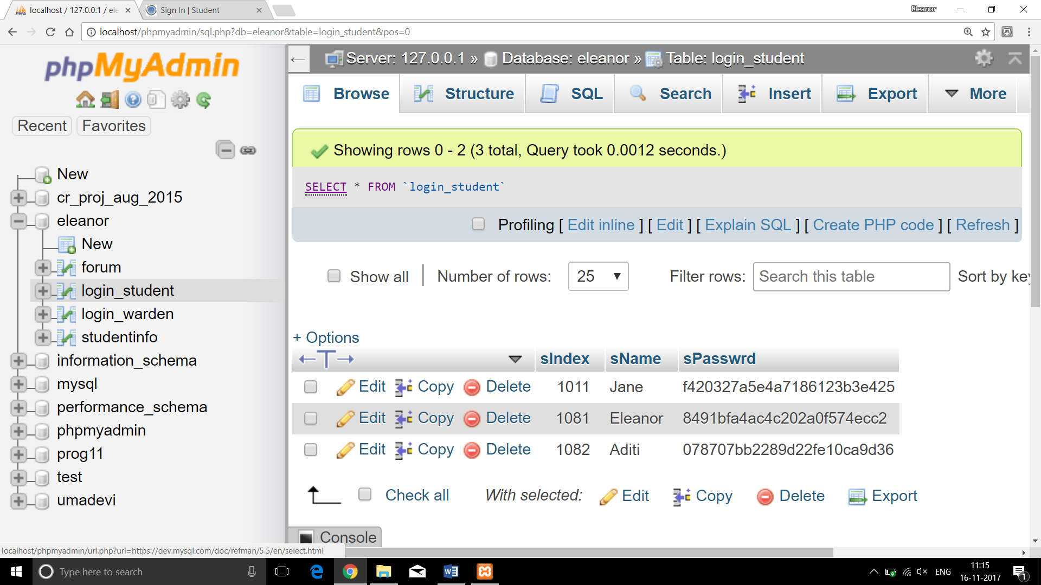

3.3 Student Information

3.3.1 Description

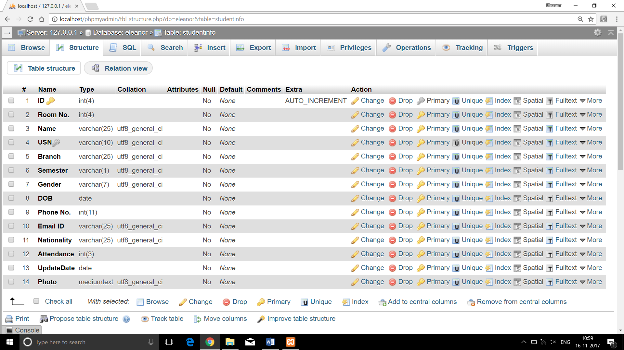

3.3.2 Data

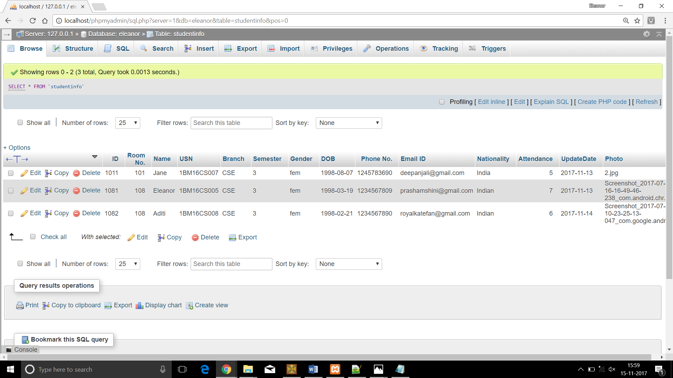

3.4 Discussion/Enquiry Forum

3.4.1 Description

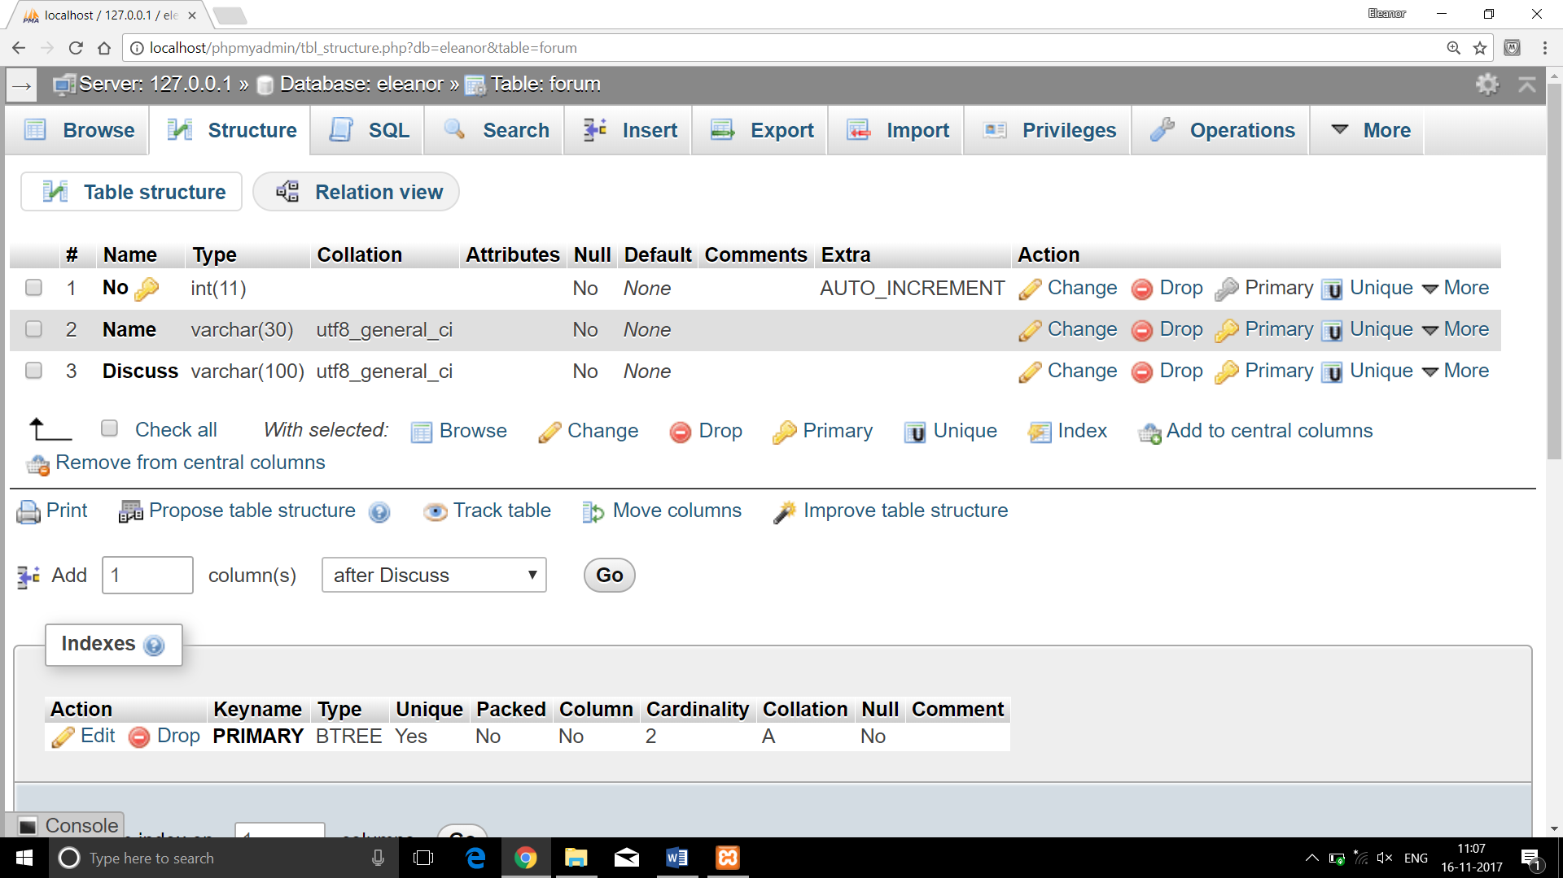

3.4.2 Data

